# Predicting Winners & Losers With CPI & GDP

Can a combination of Inflation (CPI), and 2 proxies for GDP. The proxies are ISM PMI and ISM NMI, which correspond to ISM Purchasing Manager’s Index and ISM Non-Manufacturing Index respectively. In addition to the released values, we look at forecasts of each of the above series to see if accurate forecasts can assist in forward-looking asset allocation decisions.

## **Methodology**

Total return indices are created for each ETF used in the study, along with two representative portfolios of traditional asset allocation strategies. One is a 60/40 Stocks/Bonds portfolio, and another is a naïve volatility-weighted multi-asset portfolio, which includes debt, equity and commodities exposure.

These total return indices are then used along with Turnleaf Analytics’ CPI & ISM forecasts to construct trading rules using a model-driven trading rule.

The trading strategies examined include a long/short trading method and a long-only trading method. The long-short strategy allows entering short positions and assumes 0 financing cost; the long-only trading method does not allow entering short positions, and the decisions possible are to be long an asset, or to be flat.

### **Data**

All data used cover a period from 2013 – 2023.

#### **CPI, PMI & NMI**

Several data sets from Turnleaf Analytics were used to carry out this project. The first is a multi-variate series of data containing US YoY Change in CPI forecasts, non-seasonally adjusted, for forward looking periods ranging from 1 month — 12 months, with a periodicity of 1 month. Additional data sets include 1-month—12-month predictions of ISM PMI (Purchasing Manufacturer’s Index) and ISM NMI (Non-Manufacturing Index). The latter two data series are meant to serve as a proxy for future GDP.

#### **ETFs & Total Return Estimation**

The ETFs chosen for this study cover Equities, Debt and Commodities markets. Each asset class has a representative ETF which tracks the broader asset class - AGG for fixed income ETFs, SPY for equities ETFs and DBC/GSG for commodities ETFs. A total of 64 ETFs were used for analysis; 19 of these were selected to discuss in greater detail, and are shown in the table below.

|  |  |  |
| --- | --- | --- |
| **Class** | **Ticker** | **Name** |
| **Debt** | **AGG** | iShares Core U.S. Aggregate Bond ETF |
| **Debt** | **VCIT** | Vanguard Intermediate-Term Corporate Bond ETF |
| **Debt** | **SPIB** | SPDR Portfolio Intermediate Term Corporate Bond ETF |
| **Debt** | **BSV** | Vanguard Short-Term Bond ETF |
| **Debt** | **JNK** | SPDR Bloomberg High Yield Bond ETF |
| **Debt** | **TBT** | ProShares UltraShort 20+ Year Treasury *(Levered)* |
| **Debt** | **TMV** | Direxion Daily 20 Year Plus Treasury Bear 3x Levered |
| **Debt** | **VCLT** | Vanguard Long-Term Corporate Bond ETF |
| **Debt** | **LQD** | iShares iBoxx $ Investment Grade Corporate Bond ETF |
| **Debt** | **TMF** | Direxion Daily 20 Year Plus Treasury Bull 3x Levered |
| **Equity** | **SPY** | SPDR S&P 500 ETF Trust |
| **Equity** | **SPYG** | SPDR Portfolio S&P 500 Growth ETF |
| **Equity** | **SPLG** | SPDR Portfolio S&P 500 ETF |
| **Equity** | **KBE** | SPDR S&P Bank ETF |
| **Equity** | **XRT** | SPDR S&P Retail ETF |
| **Commodities** | **DBC** | Invesco DB Commodity Index Tracking Fund |
| **Commodities** | **GSG** | iShares S&P GSCI Commodity-Indexed Trust |
| **Commodities** | **UNG** | United States Natural Gas Fund LP |
| **Commodities** | **XOP** | SPDR S&P Oil & Gas Exploration & Production ETF |

#### Total Return Methodology

Adjusted closing prices are used on a rolling monthly basis to construct total return indices. The 60/40 portfolio is constructed using a monthly rebalanced ratio of 60% SPY and 40% AGG. The naïve volatility weighted portfolio is using a weighted portfolio of SPY, AGG and GLD, where each weight is $w_{i}=\frac{1}{σ_{i}}$, with a 1-year lookback period.

### Trading Rules

#### Intuition Behind PMI / NMI

Generally speaking, the interpretation of PMI and NMI values is straight forward. PMI and NMI both range from 0-100. If PMI is above 50, it can be viewed as an indication that the manufacturing sector is expanding. If PMI == 50, there is no change, and if PMI is below 50, the manufacturing sector is contracting.

Similarly for NMI – values above 50 indicate the non-manufacturing sector (services) is expanding; NMI == 50 indicates no change, and values below 50 indicate a contraction in the non-manufacturing sectors.

If PMI and NMI are persistently above 50, our intuition suggests that an economic expansion is underway and this should be reflected in equity (risky) markets. On the contrary, if PMI and NMI are persistently below 50, we would expect that less risky assets would be outperforming.

#### Intuition Behind CPI

We would expect measures such as CPI to have the most noticeable impact when trading debt instruments. If CPI remains high, intuition suggests wanting to be less exposed to risky assets (equities), and increase exposure to inflation-protection assets (commodities). If CPI remains low, we would want to do the contrary.

Note that we are not discussing the relationship of the level of interest rates, which is an important consideration when evaluating whether a given CPI trend is good or bad for risky assets.

How, then, can we make use of the intuition behind these values?

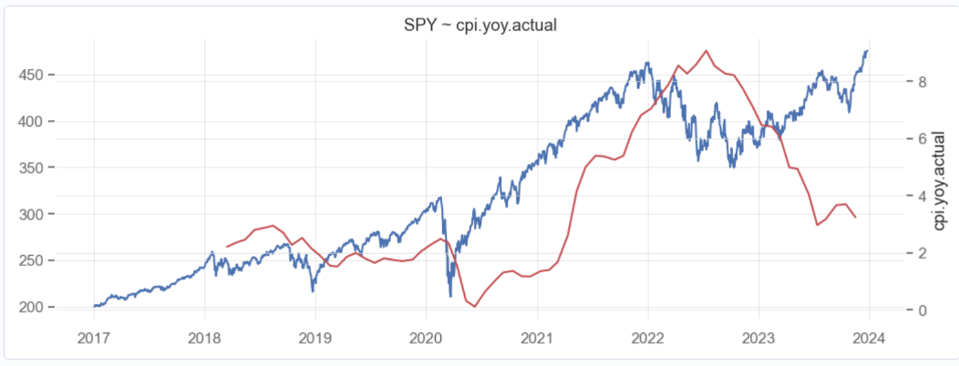

Figure 1 - SPY vs CPI YoY

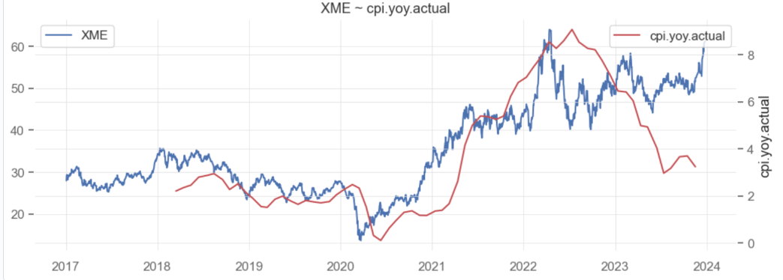

Figure 2 - XME vs CPI YoY

Looking at a time-series plot of SPY vs CPI YoY (figure 1), it’s clear that CPI lags the broader equities market. In figure 2, a plot of XME, a metals & mining sector ETF, CPI still lags the ETF performance.

#### Feature Design

What if we can partition the next-period returns using either CPI or PMI/NMI?

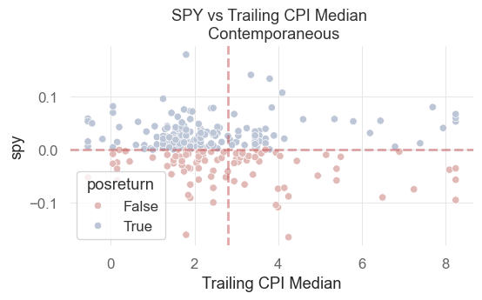

Figure 3 - SPY Returns vs 12-month trailing median CPI

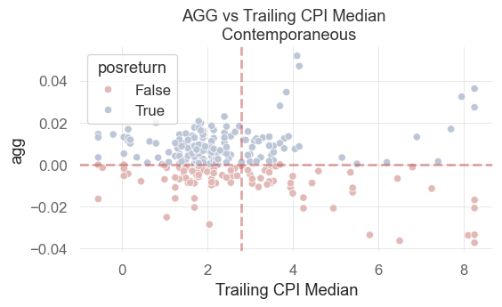

Figure 4 - AGG returns vs 12-month trailing median CPI

Examining the scatter plots in Figures 3 and 4, we find what looks to be a partitioning scheme emerging. looks more promising. While far from a crystal ball, the expected return of an asset *may* have a conditional relationship on CPI’s recent relative level.

Using this approach with PMI and NMI, along with CPI, we construct a series of factors that aim to capture the intuition described earlier. Using the forecasts of CPI, NMI, PMI for the 1-month, 3-month, 6-month, 9-month and 12-month periods, a series of factors are created as follows:

1. Above/below a threshold (trailing 3-year median) for all periodicities
2. Differential between consensus estimates and CPI/PMI/NMI forecasts

#### Logistic Regression & Trading Strategy Returns

|  |  |  |  |  |  |  |  |
| --- | --- | --- | --- | --- | --- | --- | --- |
|  |  | **CAGR** | | | **Sharpe Ratio** | | |
| **Class** | **Ticker** | **Base** | **L/O** | **L/S** | **Base** | **L/O** | **L/S** |
| **Debt** | **AGG** | 1.5 | 1.7 | 1.8 | 0.3 | 0.3 | 0.5 |
| **Debt** | **VCIT** | 3.0 | 4.5 | 5.7 | 0.4 | 0.7 | 1.3 |
| **Debt** | **SPIB** | 2.7 | 3.3 | 3.7 | 0.5 | 0.7 | 1.2 |
| **Debt** | **BSV** | 1.5 | 1.7 | 1.8 | 0.7 | 0.7 | 1.3 |
| **Debt** | **JNK** | 4.6 | 5.3 | 5.3 | 0.5 | 0.6 | 1.2 |
| **Debt** | **TBT** | (5.3) | 1.8 | 4.6 | (0.2) | 0.1 | 0.2 |
| **Debt** | **TMV** | (9.9) | (1.2) | (1.4) | (0.2) | (0.0) | (0.0) |
| **Debt** | **VCLT** | 4.0 | 2.5 | 0.4 | 0.3 | 0.2 | 0.0 |
| **Debt** | **LQD** | 3.2 | 1.2 | (1.1) | 0.4 | 0.1 | (0.2) |
| **Debt** | **TMF** | (12.3) | (8.9) | (16.8) | (0.3) | (0.2) | (0.8) |
| **Equity** | **SPY** | 11.9 | 7.2 | 0.4 | 0.7 | 0.4 | 0.0 |
| **Equity** | **SPYG** | 13.0 | 13.2 | 10.9 | 0.7 | 0.7 | 0.9 |
| **Equity** | **SPLG** | 12.3 | 11.3 | 8.0 | 0.7 | 0.7 | 0.8 |
| **Equity** | **KBE** | 3.6 | 1.1 | (6.6) | 0.1 | 0.0 | (0.4) |
| **Equity** | **XRT** | 7.6 | 3.1 | (9.0) | 0.3 | 0.1 | (0.7) |
| **Commodities** | **DBC** | 8.3 | 6.8 | 3.9 | 0.5 | 0.4 | 0.3 |
| **Commodities** | **GSG** | 5.3 | 6.4 | 4.0 | 0.2 | 0.3 | 0.3 |
| **Commodities** | **UNG** | (14.9) | (11.0) | (20.2) | (0.3) | (0.2) | (0.6) |
| **Commodities** | **XOP** | 0.2 | 1.1 | (19.5) | 0.0 | 0.0 | (0.9) |